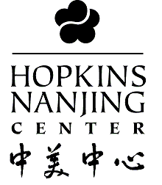
Are you interested in

GRADUATE STUDY
in CHINA?

www.nanjing.jhu.edu
Come learn about the
Hopkins-Nanjing Center

Wednesday, Sept. 21st
12:00pm
Stein 423
The Hopkins-Nanjing Center is the only graduate program of its kind –
a collaborative effort jointly administered by The Johns Hopkins University and Nanjing University. Students take international relations, economics, law and Chinese studies courses taught by Chinese professors in Chinese, mastering and transforming their Chinese language skills into an academically and professionally applicable asset. 1-year Certificate and 2-year Master’s programs offered.


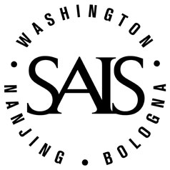
Also check out our programs online at www.nanjing.jhu.edu!

